MODULE 3 – LINKED LIST (CORE LINEAR DATA STRUCTURE)

1. What is a Linked List
- Linked List is a linear data structure
- Data is stored in nodes
- Each node contains:
  - data
  - reference (address) to next node
- Memory is non-contiguous
Meaning
Linked List trades fast insertion/deletion for slow access.

2. Why Linked List Over Array
- Dynamic size
- No shifting during insertion/deletion
- Efficient memory usage for dynamic data

3. Linked List vs Array (Interview View)
- Array
  - Fixed size
  - Fast access O(1)
  - Costly insertion O(n)
- Linked List
  - Dynamic size
  - Slow access O(n)
  - Fast insertion O(1)

4. Node Structure (Foundation)
class Node {
int data;
Node next;

Node(int data) {
this.data = data;
this.next = null;
}
}

5. Types of Linked List

A. Singly Linked List
[data|next] -> [data|next] -> [data|null]

B. Doubly Linked List
null <- [prev|data|next] <-> [prev|data|next] -> null

C. Circular Linked List
[last] -> [first]

🔹 SINGLY LINKED LIST (FULL IMPLEMENTATION)

6. Singly Linked List Structure
class SinglyLinkedList {
Node head;
}

7. Traversal
[data|next] -> [data|next] -> [data|null]
void traverse(Node head) {
Node temp = head;
while (temp != null) {
System.out.print(temp.data + " ");
temp = temp.next; // link to next node
}
}
- Time → O(n)

8. Insertion Operations

Insert at Beginning
Node insertAtBegin(Node head, int data) {
Node newNode = new Node(data);
newNode.next = head;
return newNode;
}
- Time → O(1)

Insert at End
Node insertAtEnd(Node head, int data) {
Node newNode = new Node(data);

if (head == null) return newNode;

Node temp = head;
while (temp.next != null) {
temp = temp.next;
}
temp.next = newNode;
return head;
}
- Time → O(n)

Insert at Position
Node insertAtPos(Node head, int pos, int data) {
if (pos == 0) return insertAtBegin(head, data);

Node temp = head;
for (int i = 0; i < pos - 1 && temp != null; i++) {
temp = temp.next;
}

Node newNode = new Node(data);
newNode.next = temp.next;
temp.next = newNode;

return head;
}

9. Deletion Operations

Delete from Beginning
Node deleteBegin(Node head) {
if (head == null) return null;
return head.next;
}

Delete from End
Node deleteEnd(Node head) {
if (head == null || head.next == null) return null;

Node temp = head;
while (temp.next.next != null) {
temp = temp.next;
}
temp.next = null;
return head;
}
[data,next]->[data,next] ->[data,next];

Delete by Value
Node deleteByValue(Node head, int key) {
if (head == null) return null;
if (head.data == key) return head.next;

Node temp = head;
while (temp.next != null && temp.next.data != key) {
temp = temp.next;
}

if (temp.next != null) {
temp.next = temp.next.next;
}
return head;
}

10. Search Element
boolean search(Node head, int key) {
Node temp = head;
while (temp != null) {
if (temp.data == key) return true;
temp = temp.next;
}
return false;
}

11. Reverse Linked List (VERY IMPORTANT)

Iterative Reverse
Node reverse(Node head) {
Node prev = null;
Node curr = head;

while (curr != null) {
Node next = curr.next;
curr.next = prev;
prev = curr;
curr = next;
}
return prev;
}
- Time → O(n)
- Space → O(1)
- Top interview question

12. Find Middle Element
int findMiddle(Node head) {
Node slow = head;
Node fast = head;

while (fast != null && fast.next != null) {
slow = slow.next;
fast = fast.next.next;
}
return slow.data;
}
- Two pointer technique

13. Detect Cycle (Floyd’s Algorithm)
boolean hasCycle(Node head) {
Node slow = head;
Node fast = head;

while (fast != null && fast.next != null) {
slow = slow.next;
fast = fast.next.next;

if (slow == fast) return true;
}
return false;
}

14. Remove Cycle
void removeCycle(Node head) {
Node slow = head, fast = head;

do {
slow = slow.next;
fast = fast.next.next;
} while (slow != fast);

slow = head;
while (slow.next != fast.next) {
slow = slow.next;
fast = fast.next;
}
fast.next = null;
}

15. Merge Two Sorted Linked Lists
Node merge(Node a, Node b) {
if (a == null) return b;
if (b == null) return a;

if (a.data < b.data) {
a.next = merge(a.next, b);
return a;
} else {
b.next = merge(a, b.next);
return b;
}
}

🔹 DOUBLY LINKED LIST (CORE CONCEPT)

Node Structure
class DNode {
int data;
DNode prev, next;

DNode(int data) {
this.data = data;
}
}

Advantages
- Bidirectional traversal
- Easy deletion
Disadvantages
- Extra memory
- Complex logic

🔹 CIRCULAR LINKED LIST (CONCEPT)

- Last node points to first
- No null pointer
- Used in:
  - Round-robin scheduling
  - Multiplayer games
  - Buffers

16. Time Complexity Summary
- Access → O(n)
- Insert at head → O(1)
- Insert at end → O(n)
- Delete → O(n)
- Reverse → O(n)

17. Common Interview Questions
- Reverse linked list
- Detect loop
- Find middle
- Merge lists
- Difference between singly & doubly

ONE-LINE INTERVIEW SUMMARY
Linked List is a dynamic linear data structure where elements are stored in nodes connected by references, enabling efficient insertion and deletion but slow access.

Below is MODULE 4 – STACK (DEEP DIVE)
implemented in pure Java, NO Collection Framework,
covered array-based + linked-list-based, with real interview problems, step-by-step logic, and full working code.
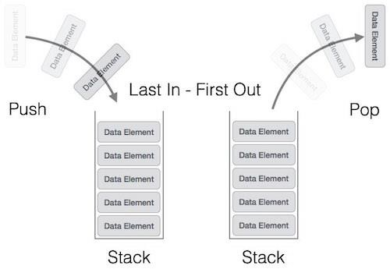
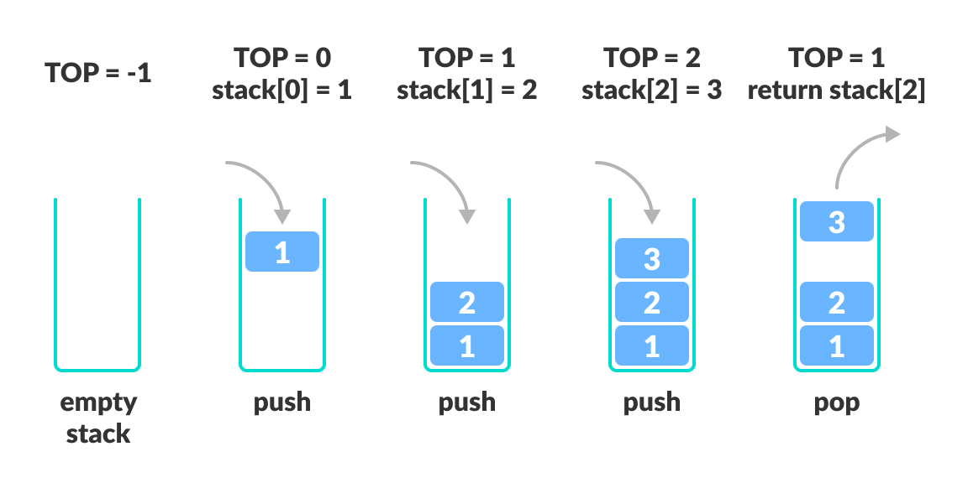
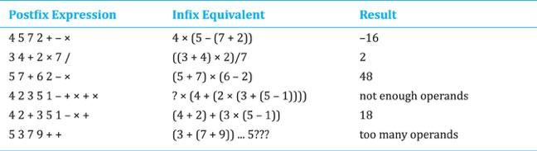

MODULE 4 – STACK (LIFO DATA STRUCTURE)

1. What is a Stack
- Stack is a linear data structure
- Follows LIFO (Last In First Out)
- Insertion and deletion happen from one end only (TOP)
Meaning
The last element inserted is the first one removed.

2. Real-Life Examples
- Stack of plates
- Undo / Redo
- Browser back button
- Function call stack

3. Stack ADT (Abstract Data Type)
Operations:
- push
- pop
- peek / top
- isEmpty
- isFull (array-based)

4. Stack Implementation Approaches
- Stack using Array
- Stack using Linked List

🔹 STACK USING ARRAY

5. Array-Based Stack Structure
class StackArray {
int[] stack;
int top;
int capacity;

StackArray(int capacity) {
this.capacity = capacity;
stack = new int[capacity];
top = -1;
}
}

6. push Operation
void push(int value) {
if (top == capacity - 1) {
System.out.println("Stack Overflow");
return;
}
stack[++top] = value;
}
- Time → O(1)

7. pop Operation
int pop() {
if (top == -1) {
System.out.println("Stack Underflow");
return -1;
}
return stack[top--];
}

8. peek Operation
int peek() {
if (top == -1) {
return -1;
}
return stack[top];
}

9. isEmpty & isFull
boolean isEmpty() {
return top == -1;
}

boolean isFull() {
return top == capacity - 1;
}

10. Display Stack
void display() {
for (int i = top; i >= 0; i--) {
System.out.print(stack[i] + " ");
}
}

11. Limitations of Array Stack
- Fixed size
- Overflow issue
- Wasted memory if stack not full

🔹 STACK USING LINKED LIST

12. Node Structure
class Node {
int data;
Node next;

Node(int data) {
this.data = data;
this.next = null;
}
}

13. Linked List Stack Structure
class StackLL {
Node top;
}

14. push Operation
void push(int value) {
Node newNode = new Node(value);
newNode.next = top;
top = newNode;
}
- Time → O(1)

15. pop Operation
int pop() {
if (top == null) {
System.out.println("Stack Underflow");
return -1;
}
int val = top.data;
top = top.next;
return val;
}

16. peek Operation
int peek() {
return top == null ? -1 : top.data;
}

17. Advantages of Linked List Stack
- Dynamic size
- No overflow
- Efficient memory usage

18. Stack Using Array vs Linked List
- Array Stack
  - Faster (cache friendly)
  - Fixed size
- Linked List Stack
  - Dynamic
  - Extra memory per node

🔹 STACK APPLICATIONS (INTERVIEW MUST)

19. Reverse a String Using Stack
char[] reverseString(char[] str) {
StackArray stack = new StackArray(str.length);

for (char c : str) {
stack.push(c);
}

for (int i = 0; i < str.length; i++) {
str[i] = (char) stack.pop();
}
return str;
}

20. Check Balanced Parentheses
boolean isBalanced(char[] exp) {
StackArray stack = new StackArray(exp.length);

for (char c : exp) {
if (c == '(' || c == '{' || c == '[') {
stack.push(c);
} else if (c == ')' || c == '}' || c == ']') {
if (stack.isEmpty()) return false;
char top = (char) stack.pop();

if ((c == ')' && top != '(') ||
(c == '}' && top != '{') ||
(c == ']' && top != '[')) {
return false;
}
}
}
return stack.isEmpty();
}

21. Infix to Postfix Conversion
int precedence(char c) {
if (c == '+' || c == '-') return 1;
if (c == '*' || c == '/') return 2;
return 0;
}
char[] infixToPostfix(char[] infix) {
StackArray stack = new StackArray(infix.length);
char[] postfix = new char[infix.length];
int k = 0;

for (char c : infix) {
if (Character.isLetterOrDigit(c)) {
postfix[k++] = c;
} else if (c == '(') {
stack.push(c);
} else if (c == ')') {
while (!stack.isEmpty() && stack.peek() != '(') {
postfix[k++] = (char) stack.pop();
}
stack.pop();
} else {
while (!stack.isEmpty() &&
precedence(c) <= precedence((char) stack.peek())) {
postfix[k++] = (char) stack.pop();
}
stack.push(c);
}
}

while (!stack.isEmpty()) {
postfix[k++] = (char) stack.pop();
}
return postfix;
}

22. Evaluate Postfix Expression
int evaluatePostfix(char[] exp) {
StackArray stack = new StackArray(exp.length);

for (char c : exp) {
if (Character.isDigit(c)) {
stack.push(c - '0');
} else {
int b = stack.pop();
int a = stack.pop();

if (c == '+') stack.push(a + b);
if (c == '-') stack.push(a - b);
if (c == '*') stack.push(a * b);
if (c == '/') stack.push(a / b);
}
}
return stack.pop();
}

23. Time & Space Complexity
- push → O(1)
- pop → O(1)
- peek → O(1)
- Space → O(n)

24. Common Interview Questions
- Stack vs Queue?
- Stack overflow vs underflow?
- How stack used in recursion?
- Parenthesis checking logic?
- Infix vs Postfix?

ONE-LINE INTERVIEW SUMMARY
Stack is a linear data structure following LIFO principle, used heavily in expression evaluation, recursion, and undo operations, implemented efficiently using arrays or linked lists.
Below is MODULE 5 – QUEUE (DEEP DIVE)
implemented in pure Java, NO Collection Framework,
covering all queue types, full working code, real interview problems, and step-by-step logic.

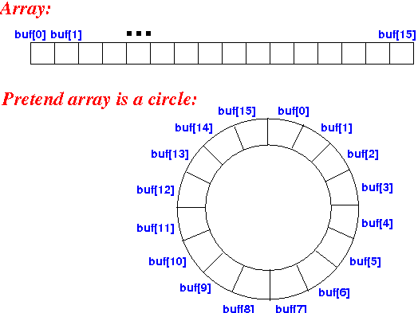

4

MODULE 5 – QUEUE (FIFO DATA STRUCTURE)

1. What is a Queue
- Queue is a linear data structure
- Follows FIFO (First In First Out)
- Insertion at REAR
- Deletion from FRONT
Meaning
The element inserted first is removed first.

2. Real-Life Examples
- Ticket counter
- CPU scheduling
- Printer queue
- Producer–Consumer model

3. Queue ADT (Abstract Data Type)
Operations:
- enqueue (insert)
- dequeue (delete)
- front
- rear
- isEmpty
- isFull (array-based)

4. Types of Queue (IMPORTANT)
- Simple Queue
- Circular Queue
- Deque (Double Ended Queue)
- Priority Queue (logic-based)

🔹 SIMPLE QUEUE USING ARRAY

5. Array-Based Queue Structure
class QueueArray {
int[] queue;
int front, rear, capacity;

QueueArray(int capacity) {
this.capacity = capacity;
queue = new int[capacity];
front = 0;
rear = -1;
}
}

6. enqueue Operation
void enqueue(int value) {
if (rear == capacity - 1) {
System.out.println("Queue Overflow");
return;
}
queue[++rear] = value;
}

7. dequeue Operation
int dequeue() {
if (front > rear) {
System.out.println("Queue Underflow");
return -1;
}
return queue[front++];
}

8. Problems with Simple Queue
- Wasted space after dequeue
- Cannot reuse freed positions
- Inefficient for long-running systems

🔹 CIRCULAR QUEUE (VERY IMPORTANT)

9. Why Circular Queue
- Reuses freed space
- Solves array queue limitation
- Used in buffers & scheduling

10. Circular Queue Structure
class CircularQueue {
int[] queue;
int front, rear, capacity;

CircularQueue(int capacity) {
this.capacity = capacity;
queue = new int[capacity];
front = -1;
rear = -1;
}
}

11. isEmpty & isFull
boolean isEmpty() {
return front == -1;
}

boolean isFull() {
return (rear + 1) % capacity == front;
}

12. enqueue (Circular Logic)
void enqueue(int value) {
if (isFull()) {
System.out.println("Queue Full");
return;
}

if (front == -1) front = 0;

rear = (rear + 1) % capacity;
queue[rear] = value;
}

13. dequeue (Circular Logic)
int dequeue() {
if (isEmpty()) {
System.out.println("Queue Empty");
return -1;
}

int value = queue[front];

if (front == rear) {
front = rear = -1;
} else {
front = (front + 1) % capacity;
}
return value;
}

14. Display Circular Queue
void display() {
if (isEmpty()) return;

int i = front;
while (true) {
System.out.print(queue[i] + " ");
if (i == rear) break;
i = (i + 1) % capacity;
}
}

🔹 QUEUE USING LINKED LIST

15. Node Structure
class Node {
int data;
Node next;

Node(int data) {
this.data = data;
this.next = null;
}
}

16. Queue Using Linked List
class QueueLL {
Node front, rear;
}

17. enqueue Operation
void enqueue(int value) {
Node newNode = new Node(value);

if (rear == null) {
front = rear = newNode;
return;
}
rear.next = newNode;
rear = newNode;
}

18. dequeue Operation
int dequeue() {
if (front == null) {
System.out.println("Queue Empty");
return -1;
}

int val = front.data;
front = front.next;

if (front == null) rear = null;
return val;
}

19. Advantages of Linked List Queue
- Dynamic size
- No overflow
- Efficient memory usage

